Christopher Horyczun
Assignment 3

Problem Solving:
To use what we learned about abstract classes, interface, and ArrayLists. We will create a table to show dog breeds to their abilities.
Understanding:
What I do Know | What I don’t Know
- How to read a file  - How to create a polymorphic array  - How to create classes | - How to make abstract classes  - How to use interfaces fully  - How to make ArrayList work fuly

Design Sketch and Hierarchy Diagram:
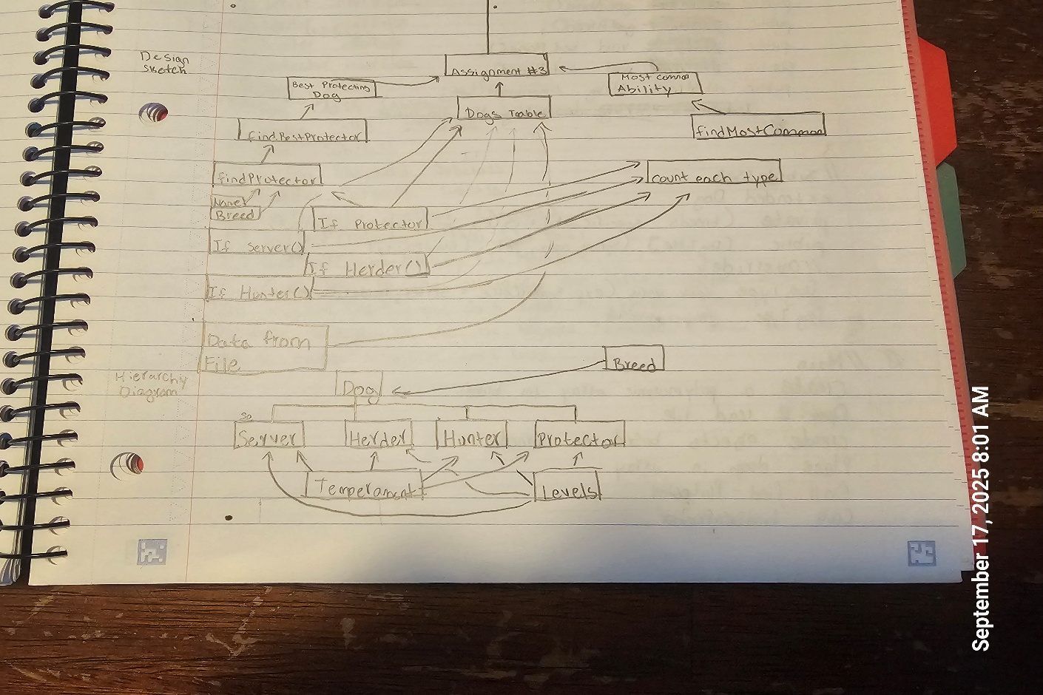
PsuedoCode:
//Main
Open file to read
Sort data from a file into array
For number of lines {
Separate into each section of the file
Separate each type of breed into there selected group (i.e. boxer, German shepherd, ect.)
}
Close file
Use ArrayList to call findProtectors
Build table for “Dogs that Protect”
for loop for each protections {
build the data within the table
}
Call best Protector method
Build data table for best protector (I.e. name, breed, temperament, protecting ability)
Calll most common method
State what is the most common ability
//end of main
//FindBestProtector
Dog best to protector to give 0
Int max to protector best (using protector interface)
For dog to protectors {
Protector p to protector d
If protector is greater then max {
Set best to d
Set max to p.protect
}
}
Return best
//end of FindBestProtector
Lesson Learned:
- I learned to use interface and that interface doesn’t go into a class
- That you don’t need to have everything abstract inside of an abstract method
- How to use the keyword ‘implements’ fully
- How to use the ArrayList

